Doc Writer: Pavan y Doc Date: Nov 24, 2015.

Application or System Name
Enrollment Initiated By EV
General Overview
- Inbound Interface to allow SAP to receive the Enrollment Request with program details (CPP or PTR) from Enrollment Vendor.
- Outbound Interface to enrollment vendor to send Enrollment Request acceptance.
Interface | Business Object | Details
Enrollment Request from EV | Inbound interface for Customer Enrollments updates | DPP Enrollment Request from Enrollment Vendor
Enrollment Request confirmation | Outbound interface - Enrollment request confirmation | DPP Enrollment request confirmation to enrollment vendor after successfully processing the incoming enrollment request

Here we have to consider three approaches:

- Option 1 - 3rd party Enrollment: This approach is similar to what is being implemented for DLA. An enrollment vendor will be used to enroll and de-enroll customers via web services
- Option 2 - CE Enrollment Approach: This approach would create all enrollment and de-enrollment capabilities within CE’S SAP systems. SAP campaign management could be leveraged to perform marketing and identification of the product assignment.
- Option 3 - Hybrid Approach: This approach combines pieces of approach 1 and 2. This is consistent with the existing business BPD.

Alternative to this object is manual exchange of information between the DPP EV and CE business, which will prone to delay in customer account updates and error resulting from manual system entries.
This will be providing CE CSR will ability to handle customer calls related to monthly bills and in general queries related to program participation.

This interface will enable sending Enrollment request confirmation to EV as soon the enrollment records is stored in DPP Enrollment table and contact update in SAP is successful .
ESB will check for mandatory information listed below:
- Customer (Customer number is not initial) ,
- Contract account (Contract account is not initial)
- Premise (Service Location is not initial)
- Program name (CPP or PTR)
- Preferences - Email (Required), Phone or SMS.

If the mandatory information check fails, the enrollment request is rejected by ESB and returned to the enrollment vendor for resolution. If the above mandatory information check passes, the enrollment request is sent to SAP near real time.

Technical Design:
Function Modules:
SAP Reconciliation Interface processing logic:
In this functionalist we will receive enrollment request from the third party system.
It has two interface BI is the middleware and we can send the data to sap and the data will be stored in the tables
- Go to transaction code ‘sproxy’ is an object navigator
Here go to Enterprise Services Browse we can see some Names (Source, SWCs, Packages, Namespaces, Object types and Objects) in Source go to ESR->SWCs->External-DPP 1.0->Namespace->EnrollmentRequest->objects.
Here we will find some service interfaces like SI_DPP_ EnrollmentRequest_in
Go to the implementation class ZCL_SI_DPP_ENROLLMENT_REQUEST and using that Instance method ZII_ SI_DPP_ENROLLMENT_REQUEST~ SI_ENROLLMENT_REQUEST_IN is called and this method will handle the enrollment request from the enrollment vendor.
In this we are creating an implementation and mapping object reference data here we getting the data we have to map it and we have process.

For this we will create a class <CREATE_MAP_IMPL_INSTANCE> this method will handle the enrollment update from the DRMS (Demand Response Management System).
In this we can find the header level values
IF ls_header-verb = 'create'(001) AND
ls_header-noun = 'EndDeviceServiceRequests'(002) AND
ls_header-source = 'EV'(003).
* return an instance of the service implementing class
CREATE OBJECT lr_ev_map_instance TYPE zcl_isu_se_map_dpp.
CREATE OBJECT lr_ev_impl_instance TYPE zcl_isu_se_impl_dpp.
y_instance_map ?= lr_ev_map_instance.
y_instance_impl ?= lr_ev_impl_instance.
lv_type = 'ZSDPP_INT_DATA'.
CREATE DATA o_dataref TYPE (lv_type).
ENDIF.
If the interface has the values it will return an instance of the service implementation class for
<ZCL_ISU_SE_MAP_DPP> is a mapping class
CALL METHOD map_dppenvrequest_in
EXPORTING
x_input = x_input
CHANGING
* xy_log =
xy_appldata = xy_output
ENDMETHOD.
By using this <MAP_DPPENVRREQUEST_IN> we can able to get the enrollment date and time also we can send SMS E-MAIL and PHONE NO.
Here we can get the enrollment process.
<ZCL_ISU_SE_IMPL_DPP> is an implementation class
<ZSDPP_INT_DATA> by using this we will map data and populate the structure
As a part of this interface we have create two tables <ZTPGM_ENROLL> is an enrollment table and stores the enrollment data.

<ZTPGM_INT_DATA> is an enrollment interface data table and stores the interface data
In this table we can get fields like <ZMSGUUID> and <ZCORRELID> is used to communicate data between the external system and our system.
In this method<PROCESS>
METHOD PROCESS.
* Initialise global variables
init( ).
* Perform Eligibility
check_eligibility( x_input ).
* Send outbound if there is any error
send_error_out( x_input ).
* Process Enrollment
process_enrollment( x_input ).
ENDMETHOD.
First it will initialize the variables in the table
Get the eligibility checks here we got the data we call DRMS validate if any error we mark it as an error.
It will send the error it will check the error and the send error message we will outbound to send the error for process DPP.
In this method<PROCESS_ENROLLMENT>
METHOD process_enrollment.
* Check for errors
CHECK gv_error = abap_false.
* Add entries in Enrollment table if there are no errors
add_enrollment( x_input ).
* Check and update contact phone number
check_update_bp_contact( x_input ).
* Send confirmation to EV.
send_pending_conf_ev( x_input ).
ENDMETHOD.
Its will checks for the error.

If there is no error it will add the entries in the enrollment tables <ZTPGM_ENROLL> and <ZTPGM_INT_DATA>.
After that it will checks and update the contact phone number or Email exist for the BP which came from the interface if does not exist we will update the BP.
Finally it will send a confirmation to EV.

System Diagram

Technical Parts Inventory
-------Name------- | ----Description---- | -----Location----- | ----Environment---
sproxy | Transaction Code |  | E2D
ZCL_SI_DPP_ENROLLMENT_REQUEST | Impl Class |  | E2D
ZCL_ISU_SE_MAP_DPP | Class |  | E2D
ZCL_ISU_SE_IMPL_DPP | Class |  | E2D
ZSDPP_INT_DATA | Structure |  | E2D
ZTPGM_ENROLL | Table |  | E2D
ZTPGM_INT_DATA | Table |  | E2D

Dependent Parts Inventory
-------Name------- | ----Description--- | -----Location----- | ----Environment---
N/A | N/A | N/A | N/A

PO Interface Technical Design Documentation:
Interface 1: CS_INT_DPP_003 - DPP Enrollment Request

Overview
This interface shall facilitate enrollment of customers into the DPP program. The interface communicates enrollment requests between the Enrollment Vendor and SAP. This allows enrollment requests to be generated in the Enrollment Vendor system and validated and recorded in SAP for full enrollment in the DPP program
Below are the interface details.
Sender Details:
Business System | ESBCORPD2
Service Interface | SI_DPP_EnrollmentRequest_Out
Namespace | http://ce.corp.com/xi/DPP/CS_INT_DPP_003/EnrollmentRequest

Receiver Details:
Business System | E2D
Service Interface | SI_DPP_EnrollmentRequest_In
Namespace | http://ce.corp.com/xi/DPP/CS_INT_DPP_003/EnrollmentRequest

Operation Mapping:
Name | None

Communication Channel Details

Sender Communication Channel
Name | sender_ESB_DPP_EnrollmentRequest
Adapter | SOAP

Screen Shot Sender Communication Channel

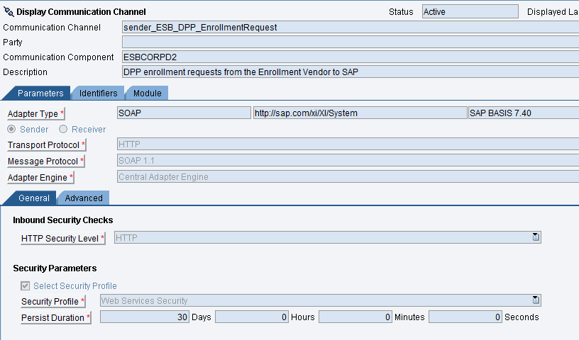

Receiver Communication Channel
Name | CC_DPP_XI_Receiver
Adapter | SOAP (ABAP Proxy)
Destination | E2DCLNT150DPP

Screenshot of Receiver Communication Channel
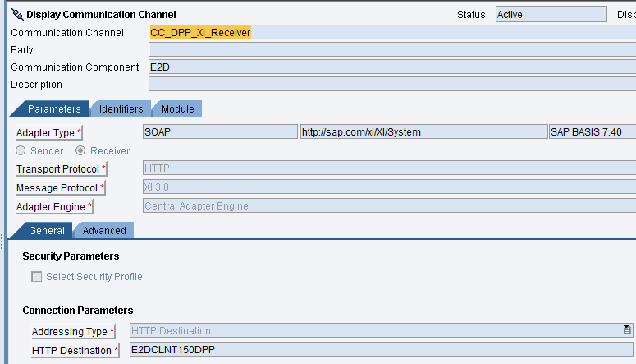

Message Mapping
No Mapping Objects exist as the Outbound and Inbound Service Interfaces use structures from same WSDL definition.
Interface 2: CS_INT_DPP_004 - DPP Enrollment Pending Confirmation
Overview
Inbound Interface to allow SAP to receive the Enrollment Request with program
This interface shall facilitate the response from SAP for the enrollment of customers into the DPP program. The interface triggers enrollment of customer preferences in iFactor. Additionally, DPP Enrollment Pending confirmation from SAP to Enrollment Vendor for requests coming from CRM to ECC is also part of this interface.
Below are the interface details.
Sender Details:
Business System | E2D
Service Interface | SI_DPP_EnrollmentPendingConf_Out
Namespace | http://ce.corp.com/xi/DPP/CS_INT_DPP_003/Enrollment_Pending_Conf

Receiver Details:
Business System | ESBCORPD2
Service Interface | SI_DPP_EnrollmentPendingConf_In  SI_DPP_EnrollmentPendingConf_CRM_In
Namespace | http://ce.corp.com/xi/DPP/CS_INT_DPP_003/Enrollment_Pending_Conf

Operation Mapping:
Name | None

Communication Channel Details

Sender Communication Channel
Name | sender_SAP_backend
Adapter | SOAP (ABAP Proxy)

Screenshot of Sender Communication Channel

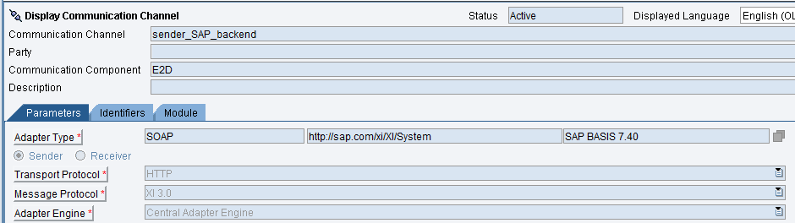

Receiver Communication Channel 1
Name | receiver_ESB_DPP_EnrollmentPendingConf
Adapter | SOAP

Screen Shot Receiver Communication Channel 1

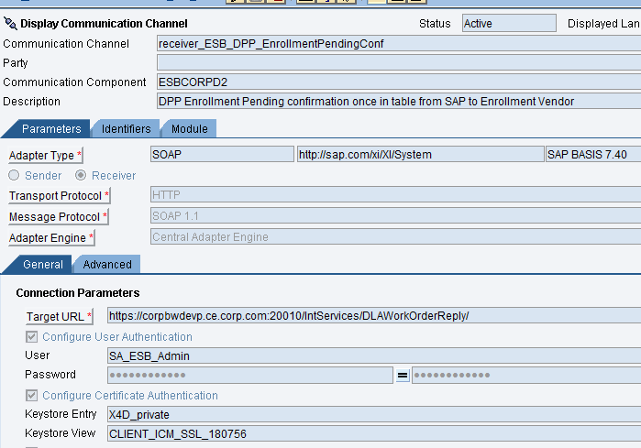

Receiver Communication Channel 2
Name | receiver_ESB_DPP_CRM_EnrollmentPendingConf
Adapter | SOAP

Screen Shot Receiver Communication Channel 2

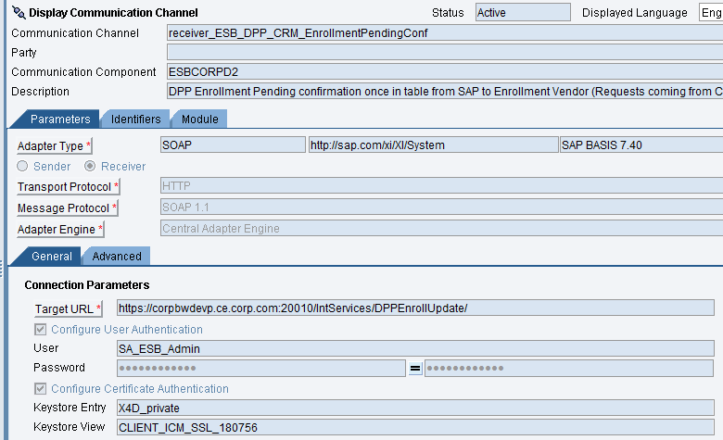

Message Mapping

No Mapping Objects exist as the Outbound and Inbound Service Interfaces use structures from same WSDL definition.

Revision History
Version | Author(s) | Date | Significant Changes
1.0 | Ed Abranovich | 01/06/15 | Approved Baseline Work Product
0.1 | Pavan y | 11/24/15 | Initial Document Release

